# CS 255 System Design Document Template

## UML Diagrams

### UML Use Case Diagram

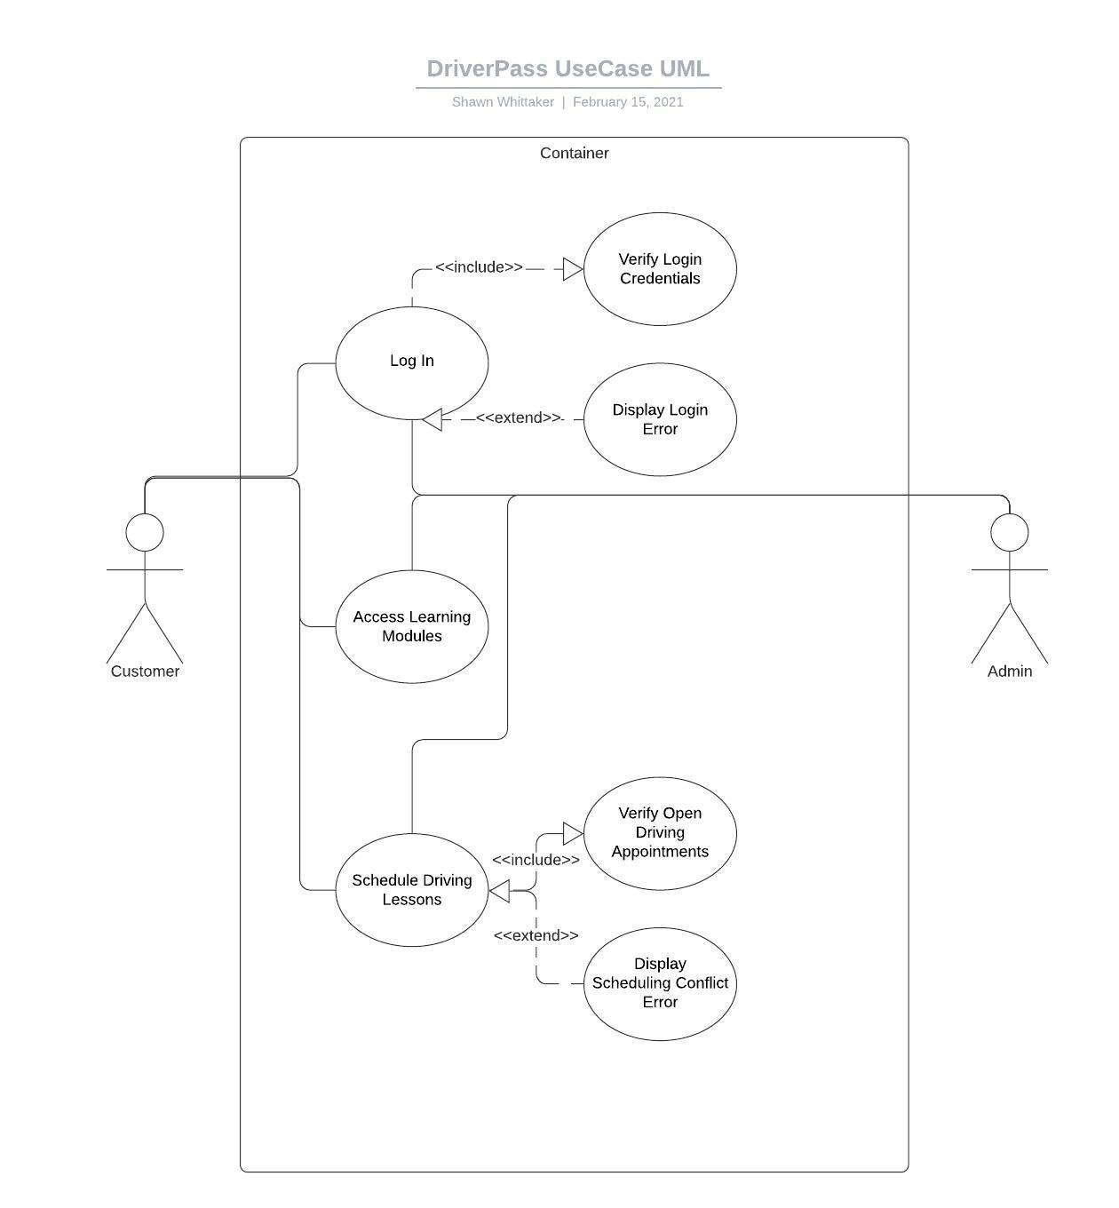

### UML Activity Diagrams

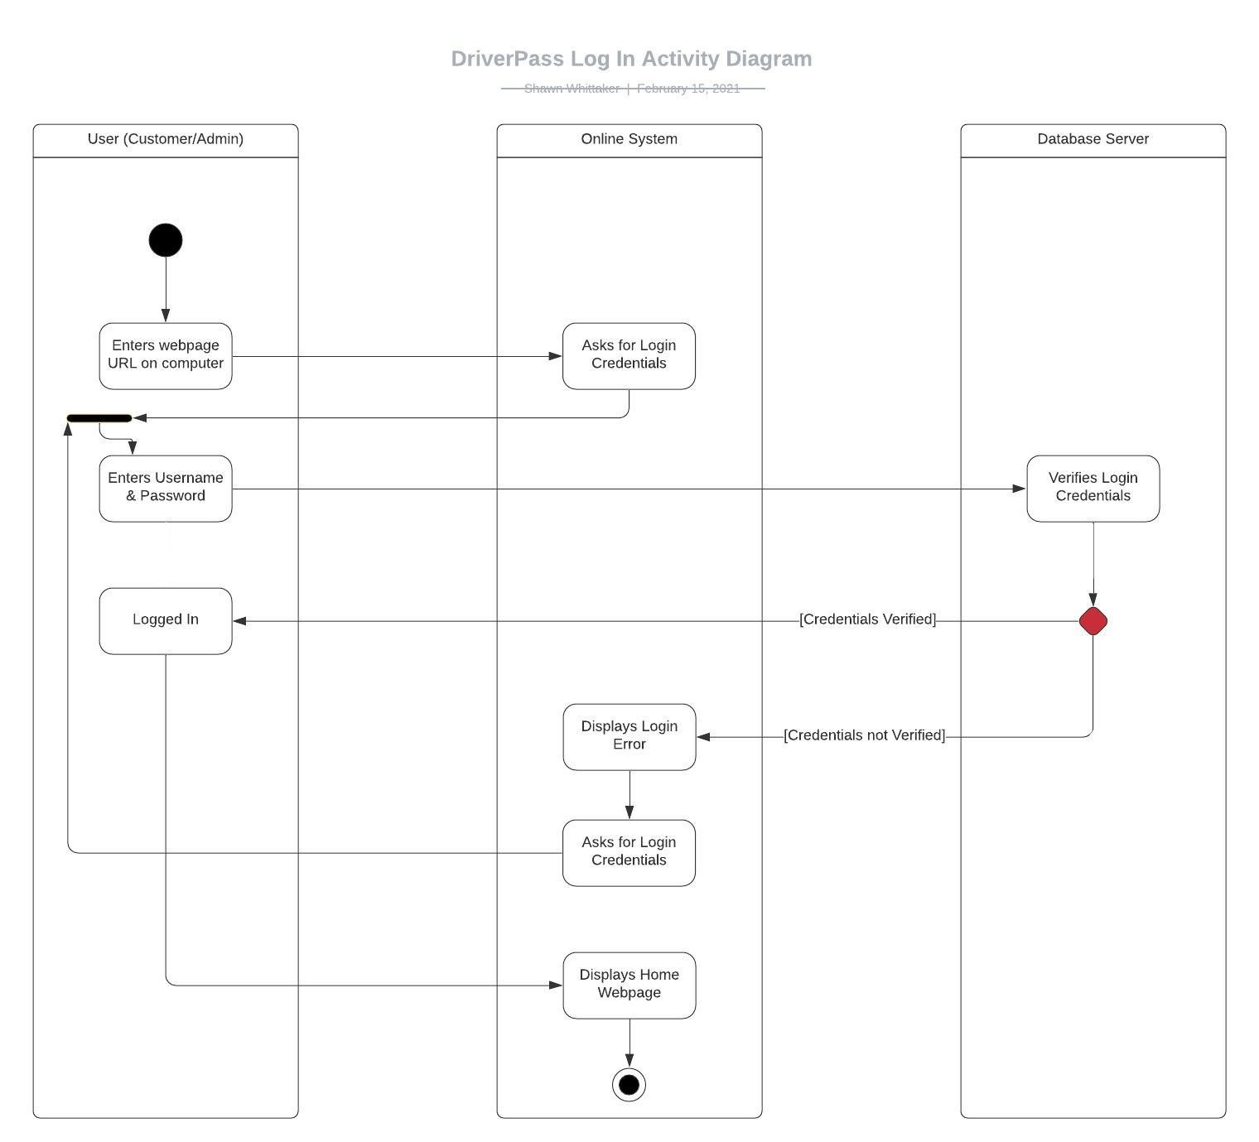

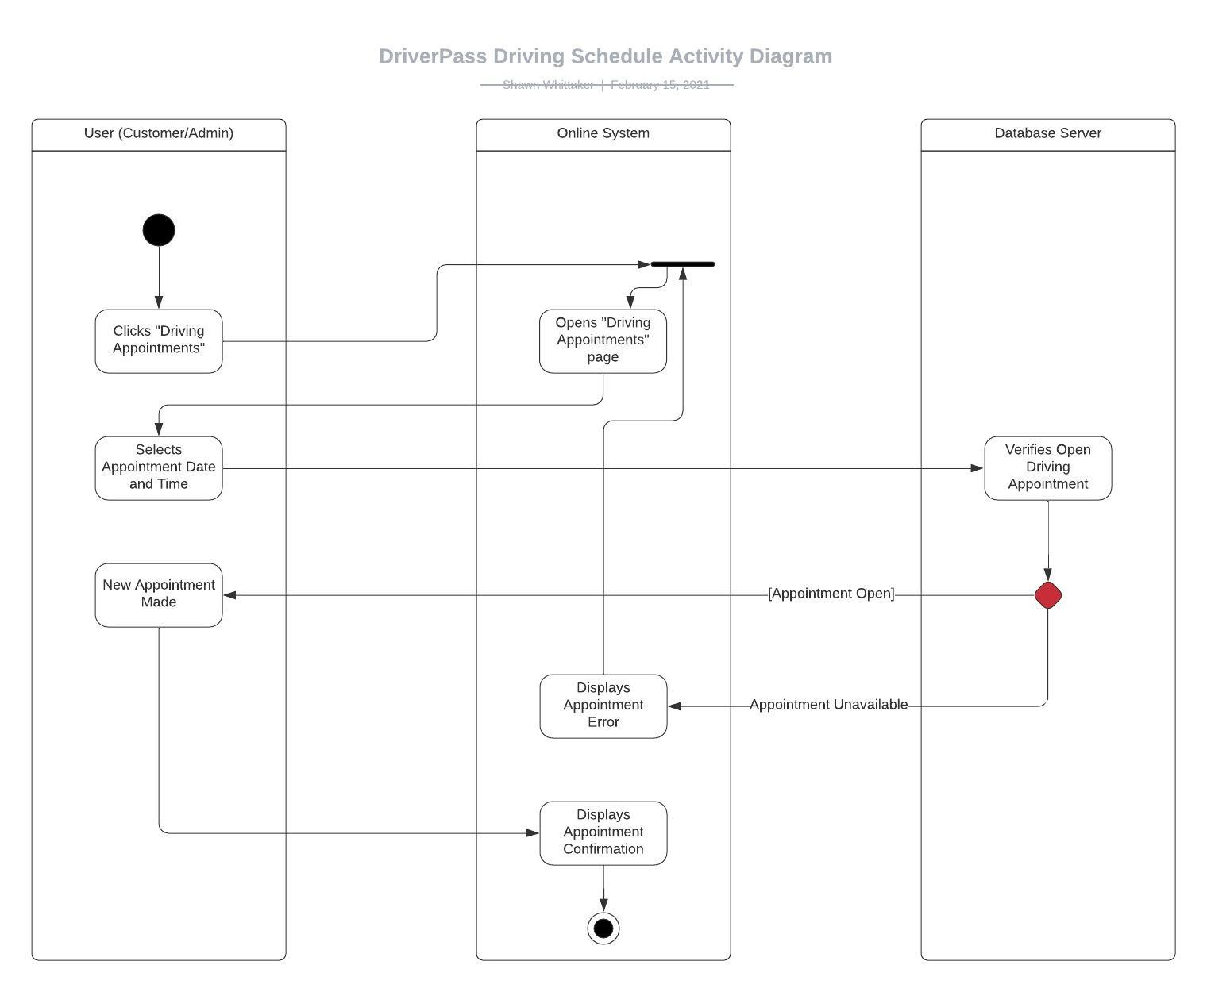

### UML Sequence Diagram

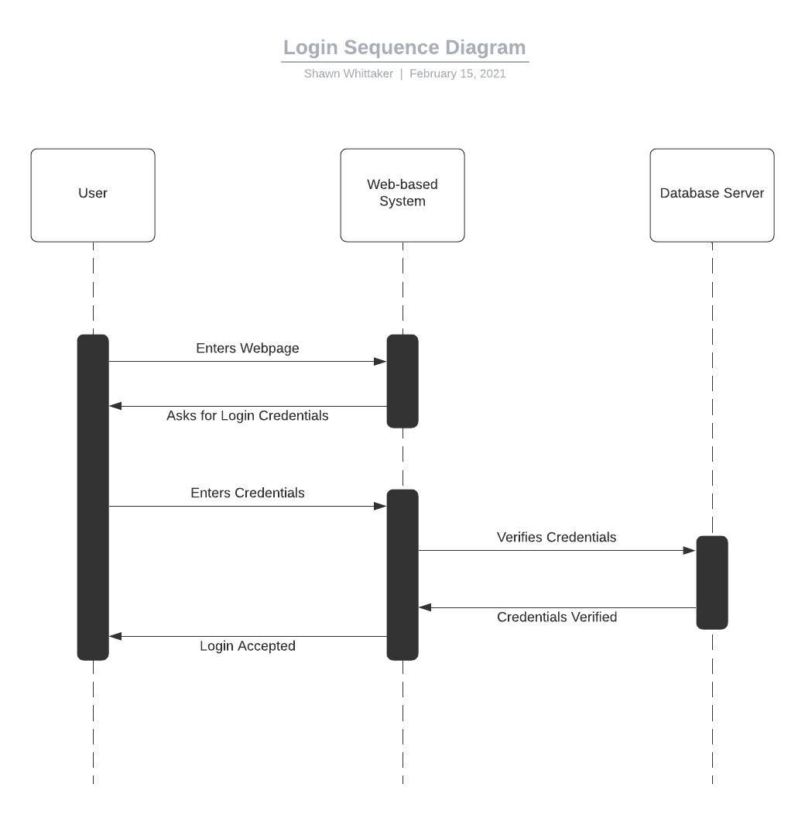

### UML Class Diagram

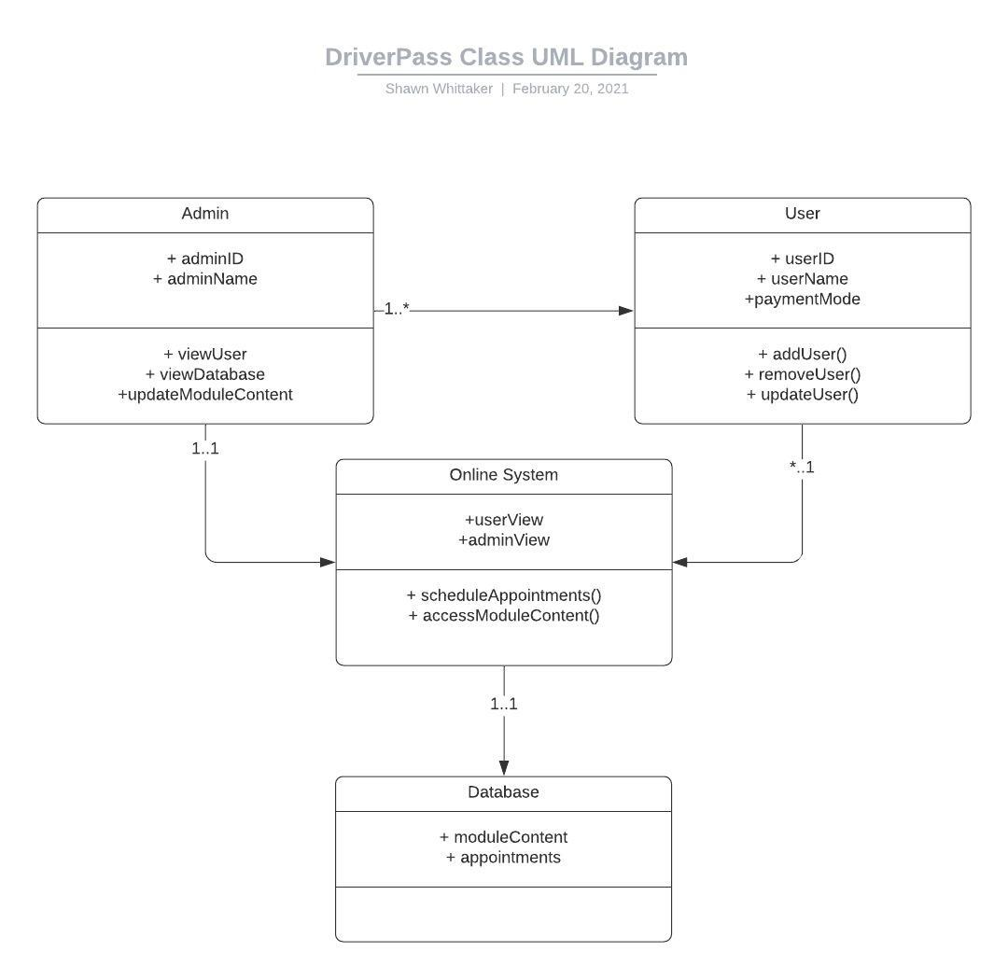

## Technical Requirements

We will need a database server, which will be holding our program application to be hosted onto the internet, as well as holding our user and admins’ credentials along with the appointments currently made and the module learning content. The server must begin with at least 1TB of storage, with the ability to add extra hard drives to accommodate an increase in data as the business grows. We will be running ASP.NET for our platform framework, which will allow us to build the application with web and mobile support, as well as allowing access into the database.